Scalar Multiplication of Vectors
1. Overview
Scalar multiplication means multiplying a vector by a single number (a scalar).
The result is another vector in which every component is multiplied by that scalar.
The lecture also connects scalar multiplication to:
- Scaling data
- Normalization of image pixel values
- Changing units, such as centimetres → metres
- Normalization and standardization in Machine Learning

2. Scalar Multiplication
What is it?
Suppose we have a vector:
$$A=\left[\begin{matrix}3 \\ 5 \\ 7\end{matrix}\right]$$
and a scalar:
$$c=4$$
Scalar multiplication means:
$$cA$$
So we multiply 4 with every component of $A$:
$$4\left[\begin{matrix}3 \\ 5 \\ 7\end{matrix}\right]=\left[\begin{matrix}4\left(3\right) \\ 4\left(5\right) \\ 4\left(7\right)\end{matrix}\right]$$
Therefore:
$$\boxed{cA=\left[\begin{matrix}12 \\ 20 \\ 28\end{matrix}\right]}$$
General formula
If:
$$A=\left[a_{1} , a_{2} , … , a_{n}\right]$$
then:
$$\boxed{cA=\left[c , a_{1} , c , a_{2}…ca_{n}\right]}$$
The dimension does not change.
$$\boxed{n\text{-dimensional vector}→n\text{-dimensional vector}}$$

3. Geometric Intuition — Scaling a Vector
Scalar multiplication becomes especially intuitive when we visualize a vector.
Suppose:
$$A=\left(2 , 2\right)$$
This vector goes from the origin toward the point:
$$\left(2 , 2\right)$$
Now multiply it by 2:
$$2A=2\left(2 , 2\right) \\ =\boxed{\left(4 , 4\right)}$$
So the vector now reaches $\left(4 , 4\right)$.
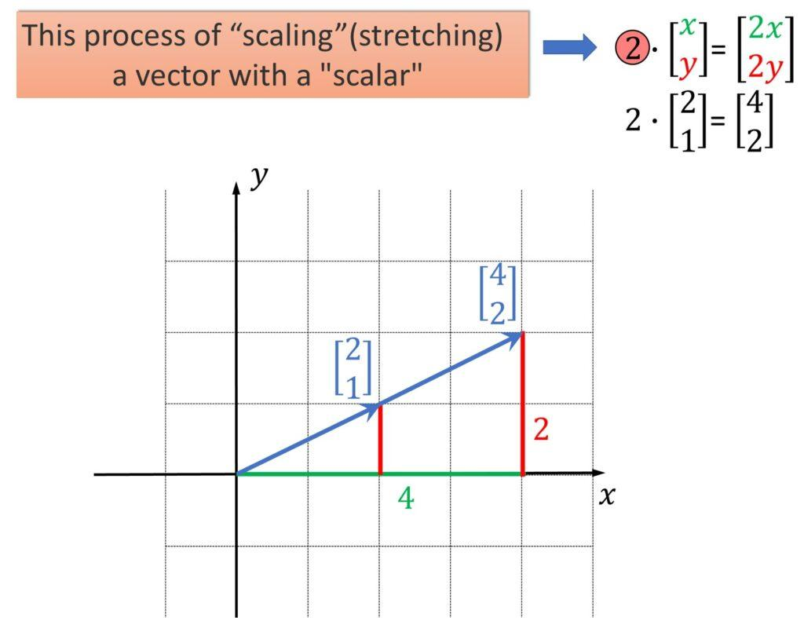
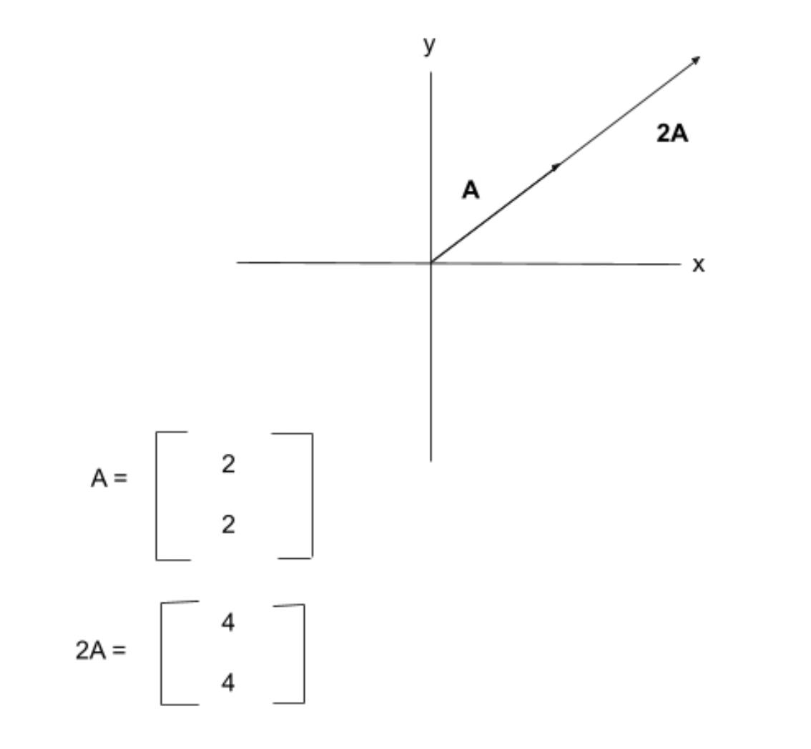
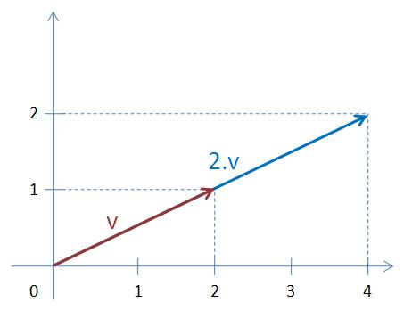
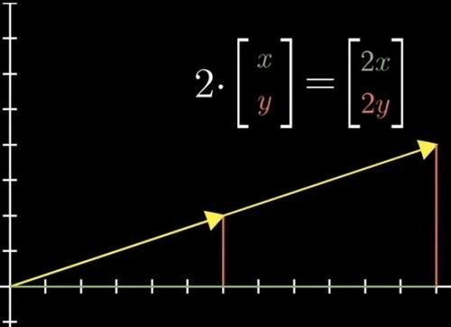
What changed?
The vector became twice as long while pointing in the same direction.
So, when multiplying a vector by a positive scalar:
$$\boxed{\text{Scalar multiplication changes the scale/magnitude of the vector.}}$$
For example:
$$A=\left(2 , 2\right) \\ 2A=\left(4 , 4\right) \\ 3A=\left(6 , 6\right)$$
The direction remains the same; the vector is stretched.

4. What Happens With Different Scalars?
The scalar determines how the vector is scaled.
Scalar greater than 1
If:
$$c=2$$
the vector becomes twice as large.
Scalar between 0 and 1
If:
$$c=0.5$$
the vector becomes half as large.
Scalar = 1
$$1A=A$$
Nothing changes.
Scalar = 0
$$0A=0$$
Every component becomes zero.
Negative scalar
A negative scalar reverses the direction of the vector as well as scaling its magnitude.
For example:
$$A=\left(2 , 3\right) \\ -2A=\left(- , 4-6\right)$$
So a useful mental model is:
Positive scalar → stretch/shrink.
Negative scalar → stretch/shrink + reverse direction.

5. Application 1 — Normalization of Image Pixels
The lecture uses image processing as an example of scalar multiplication.
Suppose we have a grayscale image.
A grayscale image has one channel, and each pixel normally has a value between:
$$\boxed{0\text{ and }255}$$
where the value represents the intensity of the pixel.
Conceptually:
- 0 → black
- 255 → white
- Values between them → shades of gray
For example:
$$\left[0 , 50 , 128 , 200 , 255\right]$$
represents pixel values.

Why scale the values?
Machine-learning and image-processing calculations can involve a very large number of numerical operations.
Instead of working with:
$$0→255$$
we can scale the pixel values to:
$$\boxed{0→1}$$
This is called normalizing the pixel values in the lecture.

How?
Divide every pixel by 255.
Mathematically:
$$\boxed{x_{\text{normalized}}=\frac{x}{255}}$$
For example:
Pixel = 0
$$\frac{0}{255}=0$$
Pixel = 128
$$\frac{128}{255}≈0.502$$
Pixel = 255
$$\frac{255}{255}=1$$
Therefore:
$$\left[0 , 128 , 255\right]$$
becomes approximately:
$$\boxed{\left[0 , 0.502 , 1\right]}$$
This is essentially scaling the entire collection of values by:
$$\frac{1}{255}$$

6. Important Terminology: Grayscale vs RGB
The lecture briefly distinguishes grayscale and colour images.
Grayscale image
Has one channel.
Pixel values:
$$0→255$$
Colour image
Typically uses three channels:
$$\boxed{R,G,B}$$
where:
- $R$= Red
- $G$= Green
- $B$= Blue
So an RGB pixel can be represented as:
$$\left[R , G , B\right]$$
For example:
$$\left[255 , 128 , 64\right]$$
The lecture mentions this distinction while explaining image normalization.

7. Application 2 — Changing Units
Scalar multiplication can also be used to change the scale or units of data.
Suppose a height feature is:
$$H=\left[160 , 170 , 180\right]$$
where the values are in centimetres.
We want to convert them to metres.
We know:
$$1\text{ cm}=0.01\text{ m}$$
Therefore, multiply every value by:
$$0.01$$
So:
$$0.01H \\ =0.01\left[160 , 170 , 180\right] \\ =\left[1.6 , 1.7 , 1.8\right]$$
Therefore:
$$\boxed{\left[160 , 170 , 180\right]\text{ cm}→\left[1.6 , 1.7 , 1.8\right]\text{ m}}$$

8. Why Is Scaling Useful in Data Science?
Different features in a dataset can have very different numerical scales.
For example:
Feature | Typical values
Age | 18–80
Height | 150–200
Salary | 20,000–200,000
Experience | 0–30
Some ML calculations are affected by differences in feature scale.
Therefore, we may transform features to more suitable numerical ranges.
The lecture connects this general idea with normalization and standardization.
Important distinction
The lecture mentions both normalization and standardization, but this particular example primarily demonstrates scaling/normalization.
You will study the detailed mathematical difference between normalization and standardization later.
For now:
Scaling changes the numerical representation of data while preserving the underlying information.

9. Scalar Multiplication and Feature Scaling
The same mathematical operation can be applied to an entire feature vector.
Suppose:
$$H=\left[160 , 170 , 180\right]$$
and the scaling factor is:
$$c=0.01$$
Then:
$$cH=\left[1.6 , 1.7 , 1.8\right]$$
So:
$$\boxed{\text{Feature vector}\underset{→}{\text{scalar multiplication}}\text{scaled feature vector}}$$
This is useful because data can be represented in a more convenient scale for subsequent calculations.

10. Connecting the Three Vector Multiplications
At this point, the lecture has covered three types of multiplication involving vectors.
1. Dot Product
$$A⋅B$$
Multiply corresponding elements and then add.
Result:
$$\boxed{\text{Scalar}}$$

2. Element-wise Multiplication
$$A⊙{B}$$
Multiply corresponding elements but don't add.
Result:
$$\boxed{\text{Vector}}$$

3. Scalar Multiplication
$$cA$$
Multiply every element of one vector by the same scalar.
Result:
$$\boxed{\text{Vector}}$$

Quick comparison
Operation | What is multiplied? | What happens afterward? | Result
Dot product | Corresponding elements of two vectors | Add the products | Scalar
Element-wise multiplication | Corresponding elements of two vectors | Keep each product | Vector
Scalar multiplication | One scalar with every vector component | Keep each scaled component | Vector
Example
Let:
$$A=\left[1 , 2 , 3\right] \\ B=\left[4 , 5 , 6\right]$$
and:
$$c=2$$
Then:
Dot product
$$A⋅B=1\left(4\right)+2\left(5\right)+3\left(6\right)=32$$
Element-wise
$$A⊙{B}=\left[4 , 10 , 18\right]$$
Scalar multiplication
$$cA=2\left[1 , 2 , 3\right]=\left[2 , 4 , 6\right]$$
This distinction is worth remembering before moving to matrix operations.

Important Formulas
Scalar multiplication
$$\boxed{cA=\left[c , a_{1} , c , a_{2}…ca_{n}\right]}$$
Image normalization example
$$\boxed{x_{\text{normalized}}=\frac{x}{255}}$$
for grayscale pixel values in the $0$-$255$ range.
Unit conversion example
$$\boxed{\text{height in }\text{metres}=0.01×\text{height in centimetres}}$$

Common Mistakes / Confusions
1. Scalar multiplication is not element-wise multiplication
In:
$$cA$$
there is one scalar $c$, which is applied to every component.
In:
$$A⊙{B}$$
there are two vectors, and corresponding components are multiplied.

2. Scalar multiplication does not normally change the vector's dimension
If:
$$A∈R^{5}$$
then:
$$cA∈R^{5}$$
The vector still has five components.

3. Don't confuse scaling with changing the underlying data
If:
$$160\text{ cm}=1.6\text{ m}$$
we have not changed the person's height.
We've only changed its numerical representation/unit.

4. Negative scalars reverse direction
If:
$$A=\left(2 , 3\right)$$
then:
$$-1A=\left(- , 2-3\right)$$
The magnitude stays the same, but the direction reverses.

Quick Revision
Core Ideas
- Scalar multiplication = multiplying a vector by one scalar.
- Every component of the vector is multiplied by the scalar.
- The resulting vector has the same dimension.
- Geometrically, positive scalar multiplication stretches or shrinks a vector.
- A negative scalar also reverses the vector's direction.
- Scaling can be used to change the numerical scale or units of data.
- Image pixels can be normalized from $0$-$255$ to $0$-$1$ by dividing by 255.
- Feature values can similarly be scaled to make numerical calculations more convenient.
Important Formulas
$$\boxed{cA=\left[c , a_{1} , c , a_{2}…ca_{n}\right]} \\ \boxed{x_{\text{normalized}}=\frac{x}{255}}$$
Data Science Connection
$$\boxed{\text{Raw Data}→\text{Scaling}→\text{More Suitable Numerical Representation}}$$
Examples:
$$\left[160 , 170 , 180\right]\text{ cm}\underset{→}{×0.01}\left[1.6 , 1.7 , 1.8\right]\text{ m}$$
and:
$$\left[0 , 128 , 255\right]\underset{→}{÷255}\left[0 , 0.502 , 1\right]$$
Self-Check
- What is scalar multiplication?
- What happens to a vector when it is multiplied by $2$, $0.5$, and $-1$?
- Calculate:
$$3\left[2 , 4 , 5\right]$$
- Why can image pixels be divided by 255?
- What is the difference between scalar multiplication and element-wise multiplication?
Final mental model
$$\boxed{\text{Scalar}×\text{Vector}→\text{Scale every component}→\text{New vector of same dimension}}$$
And with this lecture, the three vector multiplication concepts are now connected:
$$\boxed{\text{Dot Product}→\text{Scalar}} \\ \boxed{\text{Element-wise Multiplication}→\text{Vector}} \\ \boxed{\text{Scalar Multiplication}→\text{Scaled Vector}}$$

